**Notes:**

Please note the following behavior for the queries function. You are aware of all of these, but we would like to add these to the final requirements in this document to make sure they are referred to when the functionality is being built.

**Selections:**

* When geography (Zone or State) is selected, the list of training IDs for that geography should also be narrowed in the dropdown. i.e. when South South is selected - the training ID list will show all of the IDs of trainings in South South. Then if Rivers is selected, the list will reduce to just those trainings in Rivers. and so on.
* If Training ID is selected, the Training Selection section should be greyed out
* Training IDs can either be selected from a list (which narrows when Zone/State are selected) or entered manually
* Note that if LARC is selected, this does NOT include Postpartum IUCD Training, as it does in the charts. In queries, Postpartum IUCD training is listed separately and can be queried separately. LARC should only be trainings listed as LARC.
* When Annual is selected under the Time Period, the month should be greyed out under the Date Range
* When Last Month/Last 3 Months/Last 6 Months/Last 12 Months is selected, a note should display that “The last month for which data is available on the dashboard is <>” (e.g. currently December 2015)

**Aggregate Output:**

* Total facilities and reporting facilities should appear automatically when "aggregate data" is selected. Total facilities refer to all facilities listed in DHIS-2 for that geography. Reporting facilities are the facilities that reported during the month indicated in that row (month/year)
* Training Selections:
  + If training types are selected for aggregate view, display two columns for each training type: (a) the number of facilities with health workers who have completed the selected training, and (b) another column with the total number of health workers who have completed the selected training.
  + If training organizers are selected for aggregate view, display two columns for each training organizer: (a) the number of facilities with health workers who were trained by the selected organizer, and (b) another column with the total number of health workers who were trained by the selected organizer.
  + If both training types and training organizers are selected, display the two columns for each combination of training type and organizer (e.g. 2 columns for LARC by JHPIEGO, 2 columns for LARC by SMOH). See output tables.
* The column “Facilities with Trained HW in LARC” is the total number facilities with a HW trained in LARC as of the date shown in the row.

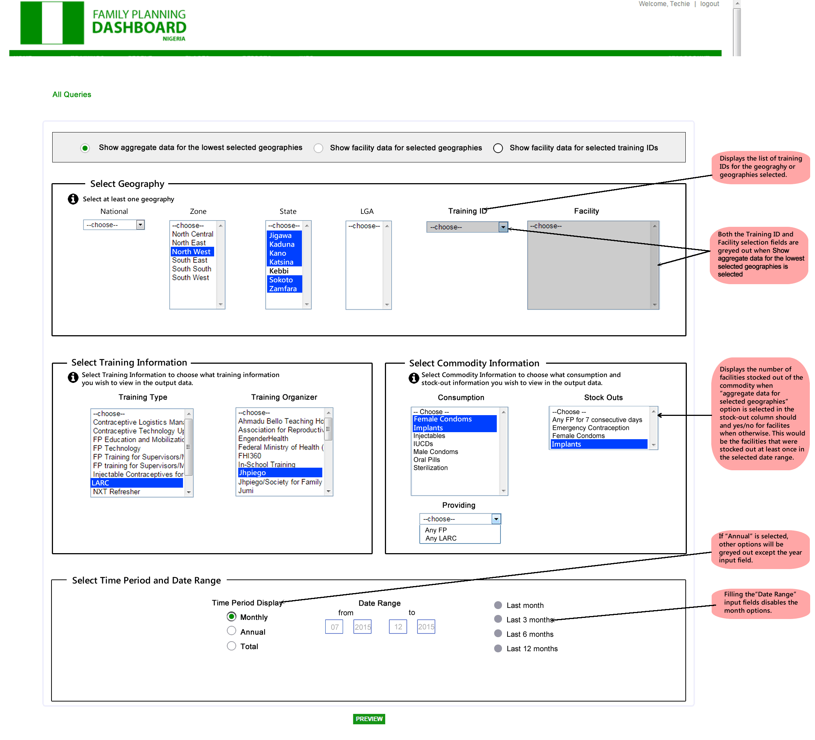

**View**: Total Data for Geography | **Geography**: Jigawa, Kaduna, Kano, Katsina, Sokoto, Zamfara |**Training Type:** LARC | **Training Organizer:** Jhpiego | **Consumption:** Implants, Female Condoms | **Stock outs:** Implants | **Time:** Monthly | **Time Period**: 7/2015 to 12/2015

**C:\Users\Gregory\Desktop\ALL FILES\UCHE\WORK\FPD\PHASE 2\MOCKUPS\RESOURCES\info button.PNG**

|  |  |  |  |  |  |  |  |  |  |
| --- | --- | --- | --- | --- | --- | --- | --- | --- | --- |
| **Geography** | **Total Facilities** | **Total Reporting Facilities** | **Facilities with a HW Trained in LARC by Jhpiego** | **HWs Trained in LARC by Jhpiego** | **Consumption of Implants** | **Consumption of Female Condoms** | **Facilities Stocked out of Implants** | **Month** | **Year** |
| Jigawa | 150 | 127 | 69 | 130 | 20 | 40 | 30 | July | 2015 |
| Kano | 300 | 290 | 78 | 210 | 18 | 31 | 35 | July | 2015 |
| Katsina | 824 | 800 | 61 | 105 | 25 | 1 | 45 | July | 2015 |
| Sokoto | 749 | 723 | 40 | 90 | 18 | 5 | 2 | July | 2015 |
| Zamfara | 283 | 275 | 9 | 200 | 0 | 0 | 13 | July | 2015 |
| Jigawa | 150 | 140 | 38 | 130 | 12 | 0 | 32 | Aug | 2015 |
| Kano | 300 | 288 | 55 | 154 | 32 | 0 | 23 | Aug | 2015 |
| Katsina | 824 | 804 | 14 | 212 | 2 | 0 | 45 | Aug | 2015 |
| Sokoto | 749 | 700 | 13 | 87 | 50 | 22 | 3 | Aug | 2015 |
| Zamfara | 283 | 268 | 9 | 115 | 11 | 60 | 11 | Aug | 2015 |

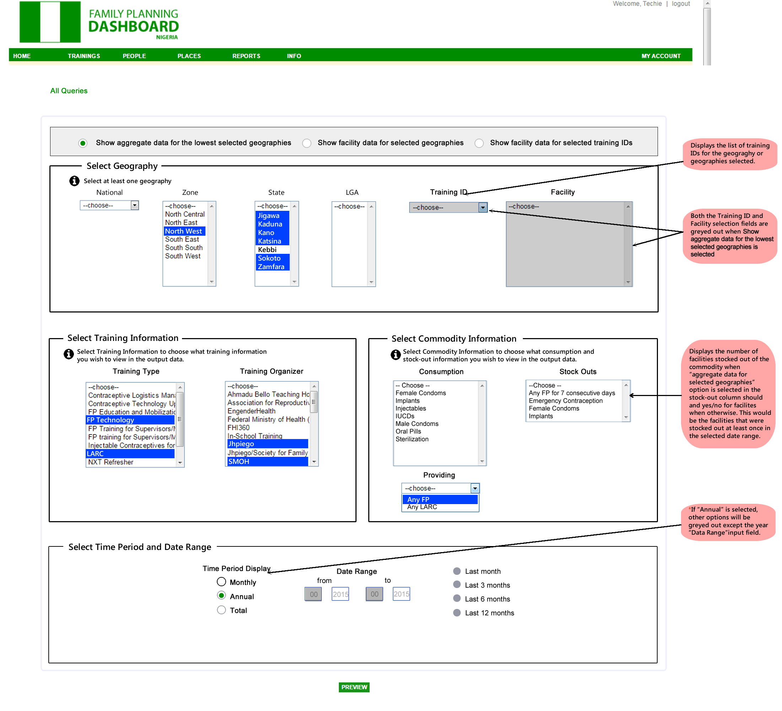

**View**: Total Data for Geography | **Geography**: Jigawa, Kaduna, Kano, Katsina, Sokoto, Zamfara |**Training Type:** LARC, FP Technology | **Training Organizer:** Jhpiego, SMOH | **Providing:** Any FP | **Time:** Annual| **Time Period**: 2015

**C:\Users\Gregory\Desktop\ALL FILES\UCHE\WORK\FPD\PHASE 2\MOCKUPS\RESOURCES\info button.PNG**

|  |  |  |  |  |  |  |  |  |  |  |  |  |
| --- | --- | --- | --- | --- | --- | --- | --- | --- | --- | --- | --- | --- |
| **Geography** | **Total Facilities** | **Total Reporting Facilities** | **Facilities with a HW Trained in LARC by Jhpiego** | **HWs Trained in LARC by Jhpiego** | **Facilities with a HW Trained in LARC by SMOH** | **HWs Trained in LARC by SMOH** | **Facilities with a HW Trained in FP Technology by Jhpiego** | **HWs Trained in FP Technology by Jhpiego** | **Facilities with a HW Trained in FP Technology by SMOH** | **HWs Trained in FP Technology by SMOH** | **Facilities Providing any FP** | **Year** |
| Jigawa | 150 | 127 | 69 | 130 | 21 | 52 | 64 | 135 | 24 | 51 | 120 | 2015 |
| Kano | 300 | 290 | 78 | 210 | 24 | 45 | 70 | 211 | 21 | 44 | 203 | 2015 |
| Katsina | 824 | 800 | 61 | 105 | 12 | 19 | 55 | 125 | 18 | 28 | 706 | 2015 |
| Sokoto | 749 | 723 | 40 | 90 | 18 | 35 | 44 | 95 | 12 | 12 | 405 | 2015 |
| Zamfara | 283 | 275 | 9 | 200 | 0 | 0 | 10 | 205 | 10 | 10 | 200 | 2015 |

**Facility level Output:**

* This refers to “Show facility data for selected geographies” and “Show facility data for selected training IDs”
* Always show state and LGA for facilities automatically when Facility level data is selected.
* The column “”HWs trained in…” should represent the cumulative number of HWs trained up to the date being shown in the row (e.g. as of Jan 2013, and then as of Feb 2013).
* If more than one training organization has trained health workers at that facility, list both with a comma
* If a training type is selected for facility views, display the number of health workers who have completed the selected training. Display the name of the training organizer.
* Note that all facilities for the selected geographies should be displayed irrespective of the selections made. If FP Technology is selected as a training type for e.g., those that don’t have a HW trained in FP Tech should show ‘0’ under ‘HW training in FP Tech’. Similarly if Providing ‘Any LARC’ is selected, display all facilities and display ‘No’ for ‘Providing any LARC’ column.
* Stock outs: If facility is stocked out any month during the selected time period, this should be yes. If facility has blank data (i.e. no stock out data) for any month during the selected time period, this should be blank. Only if facility reports no stock out for every month in the selected time period, this should be No
* The Reporting field will show up automatically - it is not a selection on the query

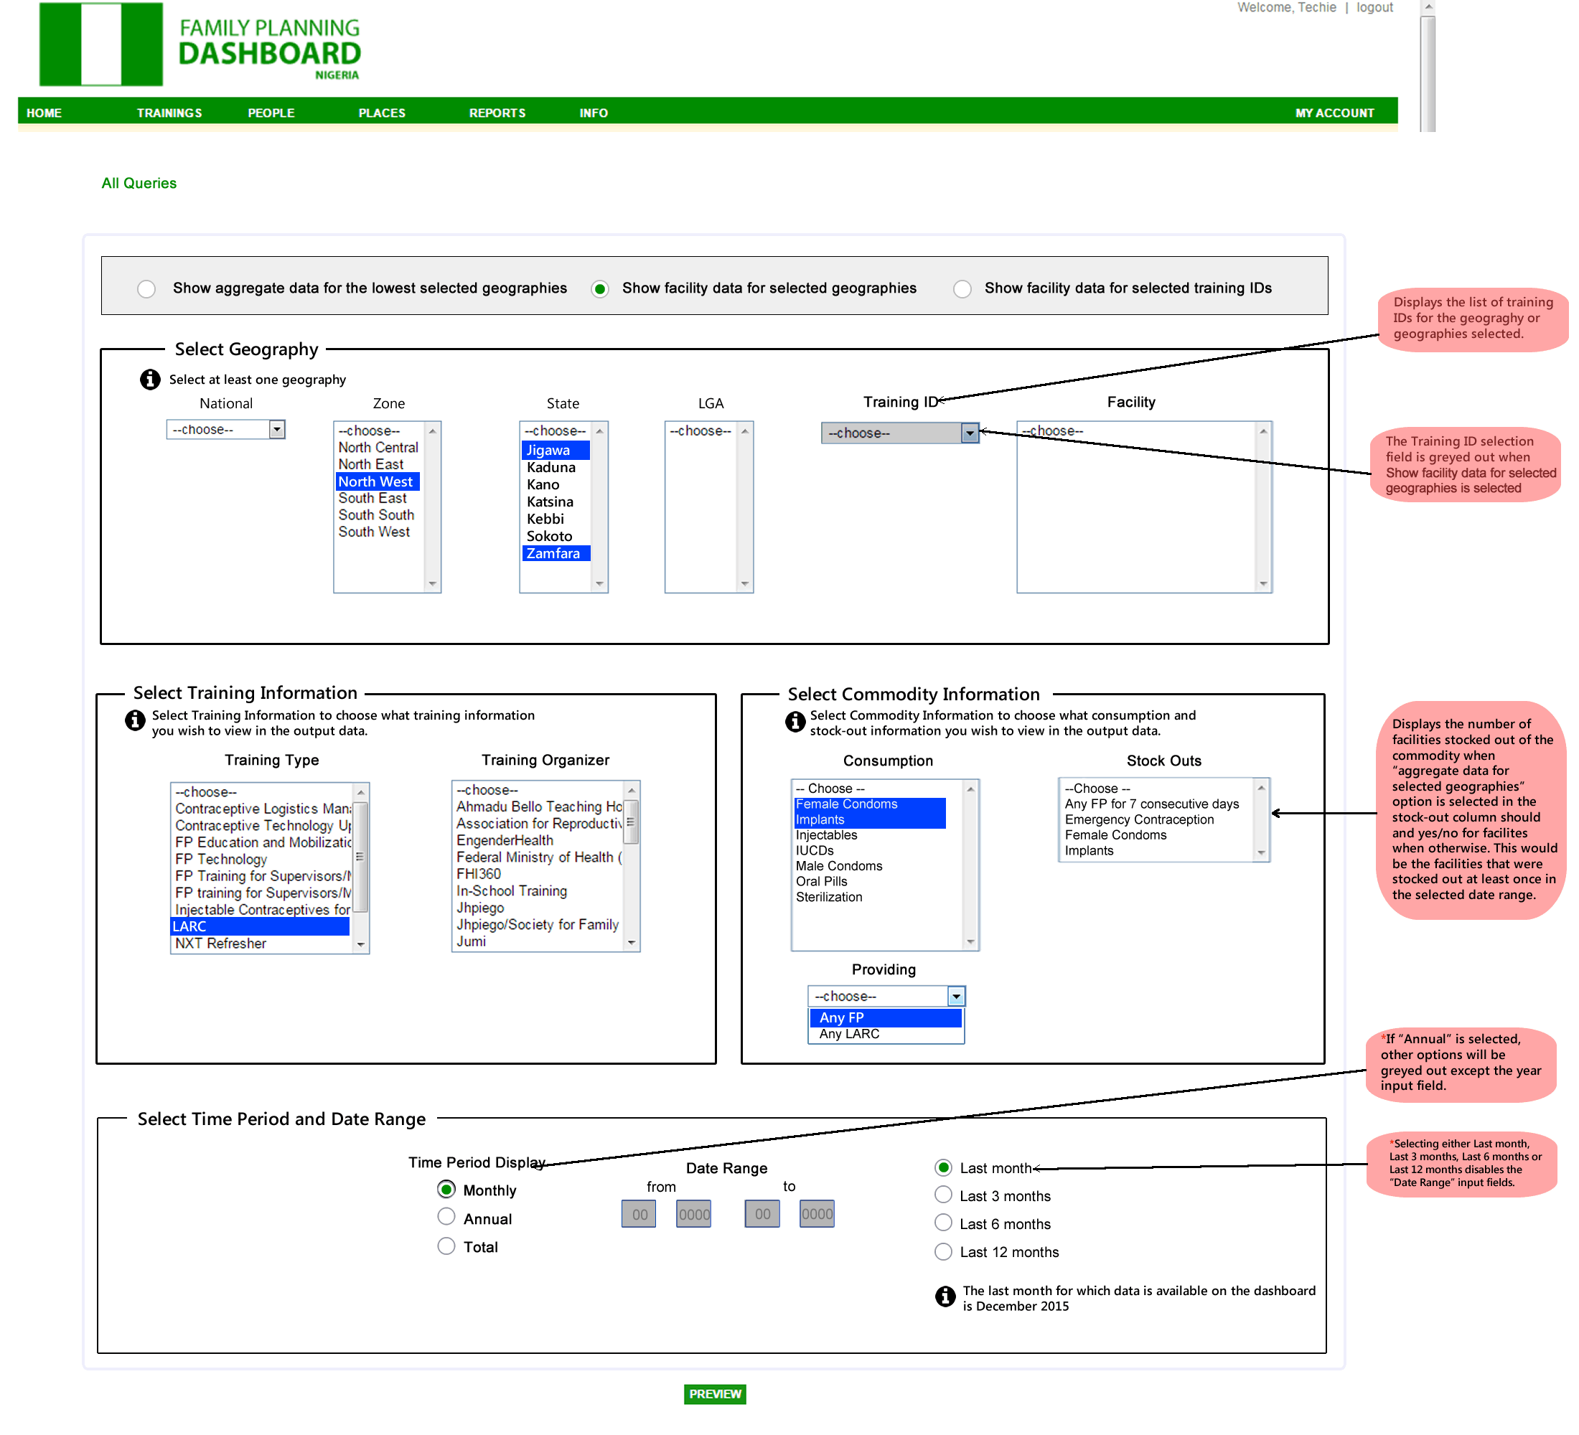

**View**: Facility View | **Geography**: Jigawa, Zamfara |**Training Type:** LARC| **Consumption:** Implants, Female Condoms | **Providing:** Any FP | **Time Period**: Last Month

**C:\Users\Gregory\Desktop\ALL FILES\UCHE\WORK\FPD\PHASE 2\MOCKUPS\RESOURCES\info button.PNG**

|  |  |  |  |  |  |  |  |  |  |
| --- | --- | --- | --- | --- | --- | --- | --- | --- | --- |
| **State** | **LGA** | **Facility** | **HWs Trained in LARC** | **Consumption of Implants** | **Consumption of Female Condoms** | **Providing Any FP** | **Month** | **Year** | **Reporting** |
| Jigawa | LGA 1 | Facility 1 | 2 | 20 | 3 | Yes | Dec | 2015 | Yes |
| Jigawa | LGA 1 | Facility 2 | 3 | 10 | 2 | Yes | Dec | 2015 | Yes |
| Jigawa | LGA 2 | Facility 3 | 5 | 3 | 0 | Yes | Dec | 2015 | No |
| Jigawa | LGA 2 | Facility 4 | 0 | 0 | 0 | No | Dec | 2015 | Yes |
| … | … | Etc. | … | … | … |  | … | … | … |
| Zamfara | LGA 1 | Facility 1 | 0 | 25 | 3 | Yes | Dec | 2015 | Yes |
| Zamfara | LGA 1 | Facility 2 | 3 | 8 | 1 | Yes | Dec | 2015 | Yes |
| Zamfara | LGA 2 | Facility 3 | 5 | 6 | 2 | Yes | Dec | 2015 | Yes |
| Zamfara | LGA 2 | Facility 4 | 0 |  |  | No | Dec | 2015 | No |
| … | … | Etc. | … | … | … |  | … | … | … |

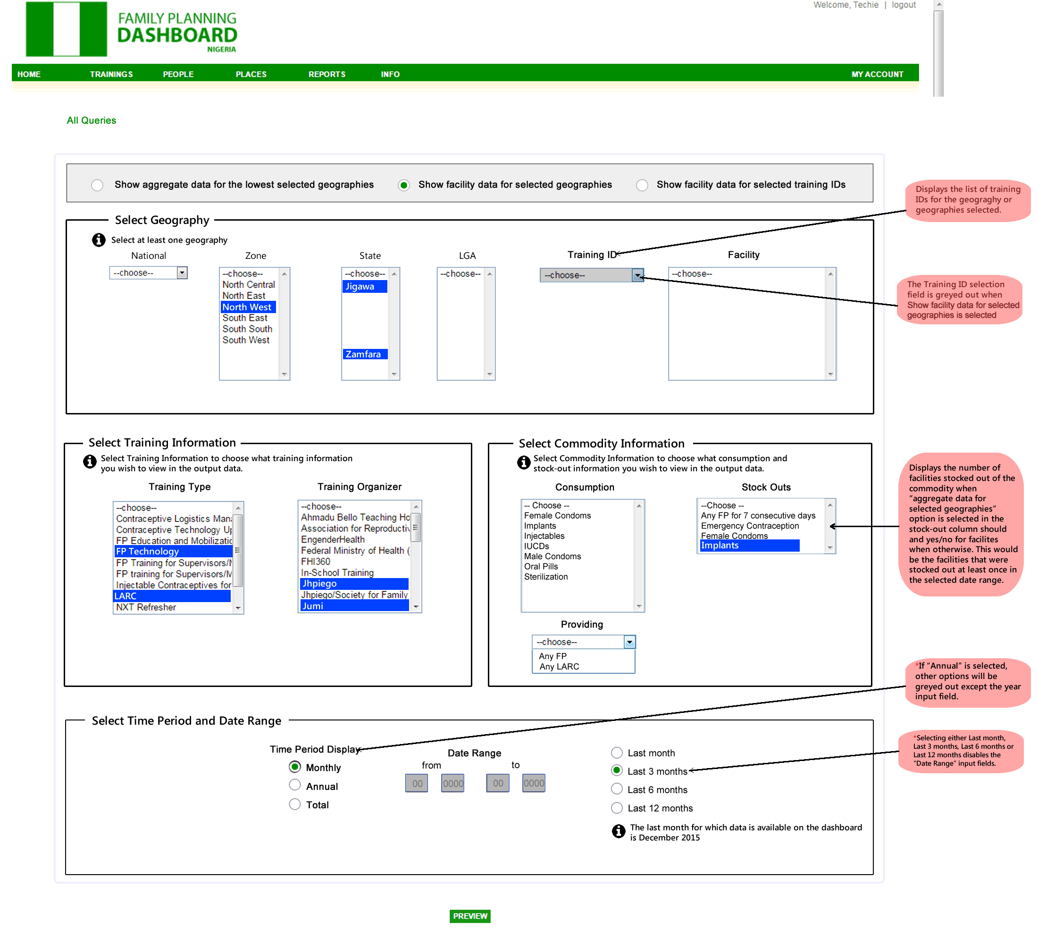

**View**: Facility View | **Geography**: Jigawa, Zamfara |**Training Type:** LARC, FP Technology | **Training Organizer:** JHPIEGO, Jumi **Stock Out:** Implants| **Time Period**: Last 3 Months

**C:\Users\Gregory\Desktop\ALL FILES\UCHE\WORK\FPD\PHASE 2\MOCKUPS\RESOURCES\info button.PNG**

|  |  |  |  |  |  |  |  |  |  |  |
| --- | --- | --- | --- | --- | --- | --- | --- | --- | --- | --- |
| **State** | **LGA** | **Facility** | **HWs Trained in LARC by Jhpiego** | **HWs Trained in LARC by Jumi** | **HWs Trained in FP Technology by Jhpiego** | **HWs Trained in FP Technology by Jumi** | **Stock out of Implants** | **Month** | **Year** | **Reporting** |
| Jigawa | LGA 1 | Facility 1 | 2 | 0 | 1 | 2 | No | Dec | 2015 | Yes |
| Jigawa | LGA 1 | Facility 2 | 3 | 0 | 3 | 1 | No | Dec | 2015 | Yes |
| Jigawa | LGA 2 | Facility 1 | 5 | 0 | 2 | 1 | - | Nov | 2015 | No |
| Jigawa | LGA 2 | Facility 2 | 0 | 0 | 1 | 0 | No | Nov | 2015 | Yes |
| … | … | Etc. | … | … |  |  | … | … | … | … |
| Zamfara | LGA 1 | Facility 1 | 0 | 1 | 2 | 1 | No | Dec | 2015 | Yes |
| Zamfara | LGA 1 | Facility 2 | 3 | 1 | 3 | 2 | Yes | Dec | 2015 | Yes |
| Zamfara | LGA 2 | Facility 1 | 5 | 0 | 0 | 3 | Yes | Nov | 2015 | Yes |
| Zamfara | LGA 2 | Facility 2 | 0 | 0 | 1 | 0 | - | Nov | 2015 | No |
| … | … | Etc. | … | … |  |  | … | … | … | … |

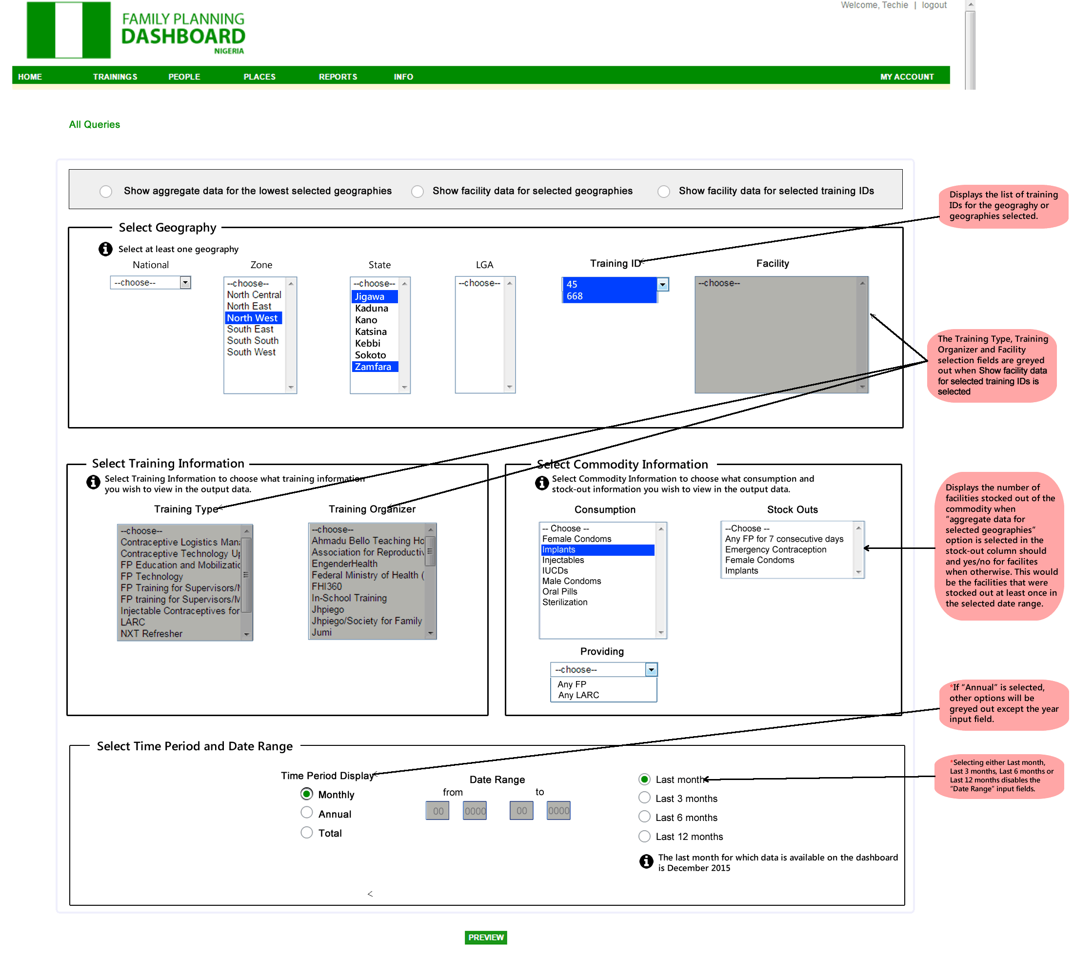

**View**: Facility View for selected training IDs | **Geography**: Jigawa, Zamfara | **Training ID**: 668, 45 | **Consumption:** Implants| **Time Period**: Last Month

**C:\Users\Gregory\Desktop\ALL FILES\UCHE\WORK\FPD\PHASE 2\MOCKUPS\RESOURCES\info button.PNG**

|  |  |  |  |  |  |  |  |  |  |  |
| --- | --- | --- | --- | --- | --- | --- | --- | --- | --- | --- |
| **State** | **LGA** | **Facility** | **HWs Trained in training** | **Training ID** | **Training Organizer** | **Training Type** | **Consumption of Implants** | **Month** | **Year** | **Reporting** |
| Jigawa | LGA 1 | Facility 1 | 2 | 668 | Nigerian Urban Reproductive Health Initiative (NURHI) | FP Technology | 13 | Dec | 2015 | Yes |
| Jigawa | LGA 1 | Facility 2 | 3 | 668 | Nigerian Urban Reproductive Health Initiative (NURHI) | FP Technology | 24 | Dec | 2015 | Yes |
| Jigawa | LGA 2 | Facility 1 | 5 | 668 | Nigerian Urban Reproductive Health Initiative (NURHI) | FP Technology | - | Dec | 2015 | No |
| Zamfara | LGA 3 | Facility 2 | 6 | 45 | Jhpiego | LARC | 10 | Dec | 2015 | Yes |
| Zamfara | LGA 3 | Facility 1 | 4 | 45 | Jhpiego | LARC | 5 | Dec | 2015 | Yes |